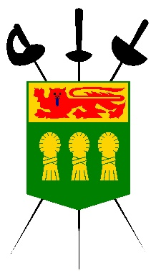

Photography/Media Release Form

I hereby authorize The Saskatchewan Fencing Association, to publish photographs taken of me on , and my name and likeness, for use in the Saskatchewan Fencing Association's print, online and video-based marketing materials, as well as other publications.

I hereby release and hold harmless the Saskatchewan Fencing Association from any reasonable expectation of privacy or confidentiality associated with the images specified above.

I further acknowledge that my participation is voluntary and that I will not receive financial compensation of any type associated with the taking or publication of these photographs or participation in company marketing materials or other publications. I acknowledge and agree that publication of said photos confers no rights of ownership or royalties whatsoever.

I hereby release the Saskatchewan Fencing Association, its contractors, its employees, and any third parties involved in the creation or publication of marketing materials, from liability for any claims by me or any third party in connection with my participation.

Authorization

Printed Name: ________________________ ____

Signature: _______________________ _________

Date: ______ ________________

Street Address: ________________________________________________________

City: _________________ ___________

Province: _____ ___

Postal Code: ______ _____________

