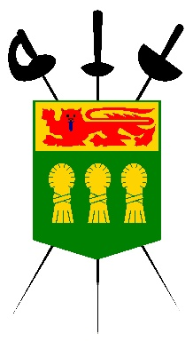

Photography/Media Release Form

I hereby authorize the Saskatchewan Fencing Association, to publish photographs taken on of myself and/or the minor child or children listed below, and our names and likenesses, for use in the Saskatchewan Fencing Association's print, online and video-based marketing materials, as well as other publications.

I hereby release and hold harmless the Saskatchewan Fencing Association from any reasonable expectation of privacy or confidentiality for myself and for the minor child and children listed below associated with the images specified above. Further, I attest that I am the parent or legal guardian of the child or children listed below and that I have full authority to consent and authorize the Saskatchewan Fencing Association to use their likenesses and names.

I further acknowledge that participation is voluntary and that neither I, the minor child, or minor children will receive financial compensation of any type associated with the taking or publication of these photographs or participation in company marketing materials or other publications. I acknowledge and agree that publication of said photos confers no rights of ownership or royalties whatsoever.

I hereby release the Saskatchewan Fencing Association, its contractors, its employees and any third parties involved in the creation or publication of Company publications, from liability for any claims by me or any third party in connection with my participation or the participation of the minor children listed below.

Authorization:

Printed Name: _______ _____________________

Signature: _____________________ ___________

Date: ______________________

Street Address: _______________________________________________________

City: _________________________ Province: __ ______

Postal Code: ___________________

Relationship to Children: _______________________________________________

Names and Ages of Minor Children:

Name: ______________________________________ Age: _____

Name: ______________________________________ Age: _____

Name: ______________________________________ Age: _____

