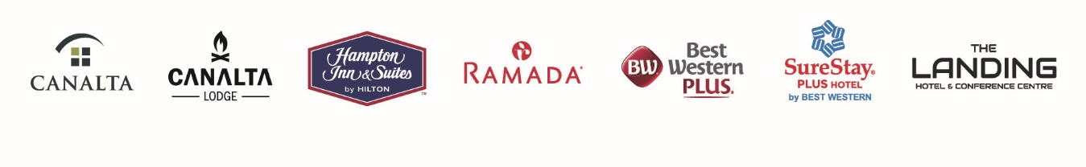

Dear Pamela,

Thank you for choosing the Canalta Melfort Hotel as your host hotel for your tournament! Please review the information below regarding your group and how your guests can make their reservations.

**Block Name:** Saskatchewan Fencing Association **Group Code: FENCING**

**Dates:** Check In October 24, 2025 and Check Out is October 26, 2025

**To Book:** 306-752-4242, or you can go online to [https://booking.hotelkeyapp.com/v2/index.html#/booking/search?pc=CH66907&property_id=efe83d17-8c6e-4a23-8f56-96a0b0a22592&from=2025-10-24&to=2025-10-26&guest=1&children=0&rate=&userid=6795719](https://booking.hotelkeyapp.com/v2/index.html#/booking/search?pc=CH66907&property_id=efe83d17-8c6e-4a23-8f56-96a0b0a22592&from=2025-10-24&to=2026-10-26&guest=1&children=0&rate=&userid=6795719)

and use group code **FENCING** to book online! Please be sure to copy this code as it is case sensitive.

**Please instruct your guests to ask for the Saskatchewan Fencing Association to ensure they receive this special rate 5% off our regular rates.**

**Please have your guests book as soon as they are able as our rates do increase with higher occupancy.**

We know how much work is involved in planning an event and want to do what we can to help check off that to-do list.

If you have any questions or need any further information, please do not hesitate to reach out directly to me.

Again, thank you for choosing the Canalta Melfort, and we look forward to hosting your guests at our hotel.

Sincerely,

Jenna Belding

Guest Service Agent

Canalta Melfort

P.O. Box 3369

100 Stonegate 500 Highway 6 South

P: (306) 752-4242

E: fdcanaltamelfort@canalta.com